HTML basics
What Is HTML, and What Role Does It Play on the Web?
HTML, which stands for Hypertext Markup Language, is a markup language for creating web pages. When you visit a website and see content like paragraphs, headings, links, images, and videos; that's HTML. HTML represents the content and structure of a webpage through the use of elements. Here's an example of a paragraph element:
<p>Hello</p>
Most elements will have an opening tag and a closing tag. Sometimes those tags are referred to as start and end tags. In between those two tags, you will have the content. This content can be text or other HTML elements. Both opening and closing tags start with a left angle bracket (<), and end with a right angle bracket (>), with the tag name placed between these angle brackets. Here is a
closer look at just the opening and closing paragraph tags:
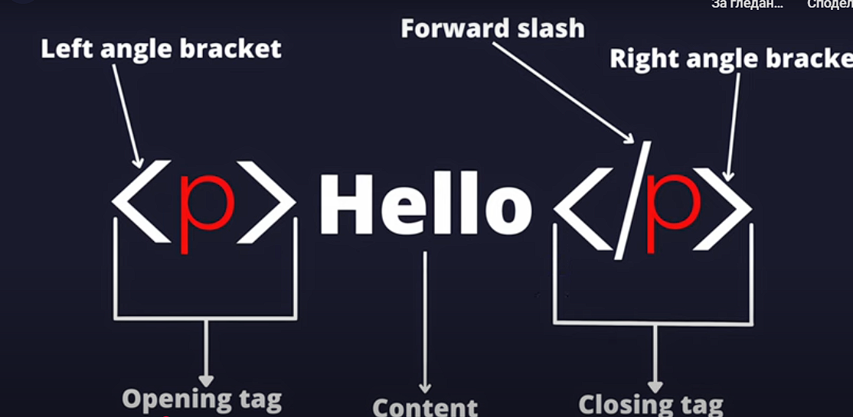

What distinguishes an opening tag from a closing tag is the forward slash (/) placed immediately after the left angle bracket in a closing tag. Some HTML elements do not have a closing tag. These are known as void elements. Here is an example of an image element which is a void element:
<img>
Notice that this image element does not have the closing tag and it does not have any content. Void elements cannot have any content and only have a start tag. If you wanted to display an image, you will need to include a couple of attributes inside your image element. An attribute is a special value used to adjust the behavior for an HTML element. Here is an example of an image element with a src, or source, attribute:
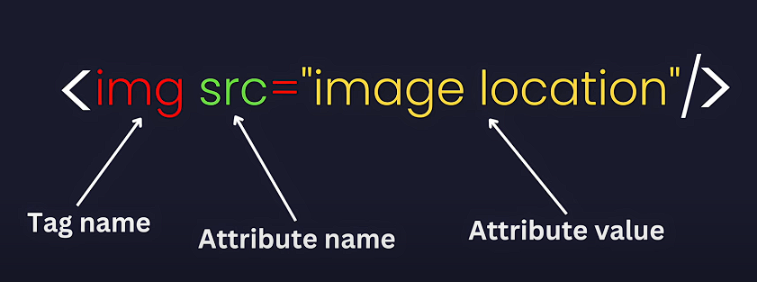

The src attribute is used to specify the location for that image. For image elements, it's good practice to include another attribute called the alt attribute. Here's an example of an image element with the src and alt attributes:
<img src="example-cat-img-url" alt="Cat sleeping in the grass">
The alt attribute is used to provide short, descriptive text for the images. In this case, the descriptive text is a "Cat sleeping in the grass".
So, you might be wondering if HTML by itself is enough to build a website. Well, the answer is: it depends. If you're building a small practice project that only displays text and images, HTML alone might be sufficient. However, if you're creating a modern professional website, you will need to have HTML, CSS, and JavaScript.
HTML is for the content and structure. CSS is for styling. JavaScript is for adding interactivity to your web pages. A good analogy for this is to compare HTML, CSS, and JavaScript with a complete building. HTML represents the blocks, concrete, and irons that make up the walls. It's the foundation that makes the building strong. CSS represents the interior and exterior design that makes the house look beautiful. JavaScript represents the electrical and water system that ensures uninterrupted access to water and electricity.

What Are Attributes, and How Do They Work?
An attribute is a value placed inside the opening tag of an HTML element. Attributes provide additional information about the element or specify how the element should behave. Here is the basic syntax for an attribute:
<element attribute="value"></element>
The attribute name is followed by an equal sign (=) and a value in quotes. The value can be a string or a number, depending on the attribute.
Let's take a look at a few examples of common HTML attributes. The first example is the href attribute, which is used to specify the URL of a link:
<a href="https://www.example-website.com">Visit our website</a>
Without this attribute, the link would not work because there would be no destination URL. So you must include this href attribute to make the link functional. Other common attributes are the src, or source, and alt, or alternative, attribute - which is used to specify the source of an image and provide alternative descriptive text for the image, respectively:
<img src="image.jpg" alt="A beautiful image" />
Similar to the href attribute, the src attribute is required because it specifies the image file to be displayed. The alt attribute is not required, but it is recommended for accessibility purposes. Accessibility means making sure that everyone, including those with disabilities, can use and understand things like websites, apps, and physical spaces. You will learn more about accessibility in the upcoming lectures.
Some attributes are a little unique with their syntax like the checked attribute shown here:
<input type="checkbox" checked />
In the following example, we have an input element with the type attribute set to checkbox. Inputs are used to collect data from users, and the type attribute specifies the type of input. In this case, this input is a checkbox. You will learn more about how inputs work in the upcoming lectures. The checked attribute is used to specify that the checkbox should be checked by default. The checked attribute does not require a value. If it is present, the checkbox will be checked by default. If the attribute is not present, the checkbox will be unchecked. This is known as a boolean attribute. You will learn more about booleans in general when you get to the JavaScript section. There are several common boolean attributes you will encounter in HTML, such as disabled, readonly, and required. These attributes are used to specify the state of an element, such as whether it is disabled, read-only, or required.
HTML has many attributes that can be used to customize the behavior and appearance of elements on a webpage. Understanding how to use attributes is essential for creating interactive and accessible web content. Over the next few lectures, you will learn about more HTML attributes and how to use them effectively in your web development projects.
What are Div Elements and When Should You Use Them?
Content Division Element - or in other words, the div:
<div></div>
I like to think of the div as a beautiful being that can be anything you want it to be. We can give a div a height, we can give it a width, and we can give it a background color using CSS - or in other words styling, which we will cover in lectures coming up.
We can also use it in a very basic form without styling, to hold other elements together. So for example, we can create a div and put a heading in it, and put a paragraph in it, and now these two elements will be grouped together:
<div>
<h1>I am a heading</h1>
<p>I am a paragraph</p>
</div>
Just be aware that there might be better elements to use when grouping these together. You might choose a section element, for example:
<section>
<h1>I am a heading</h1>
<p>I am a paragraph</p>
</section>
This is because the section element has semantic meaning. Semantics are the meaning of words or phrases in a language. In HTML, which is a language, elements have their own semantic meaning too. So, this means if you use a section element, the browser will pick up its semantic meaning and understand to treat this as a section - on desktops, mobiles, you name it.

We will dive into this topic further later on. For now, just know that the div, does not have this. It's like a mysterious ghost. Let's see what else we can do to a div, in the next lecture.
What Are IDs and Classes, and When Should You Use Them?
Let's learn about ID's and classes, and when you should use them.
The id attribute adds a unique identifier to an HTML element. In this example, there is an h1 element with an id of title:
<h1 id="title">Movie Review Page</h1>
You can reference the id name of title within your JavaScript or CSS. Here's a CSS example referencing the id of title to change the text color to red:
#title {
color: red;
}
The hash symbol (#) in front of title, tells the computer you want to target an id with that value. id names should not be used more than once, and they should always be unique. Another thing to note about id values, is that they cannot have spaces in them. Here is an example of applying the words main and heading to an id attribute value:
<h1 id="main heading">Main heading</h1>
Browsers will see this space as part of the id which will lead to unwanted issues when it comes to styling and scripting. id attribute values should only contain letters, digits, underscores, and dashes.
In contrast to the id attribute, the class attribute value does not need to be unique and can contain spaces. Here is an example of applying a class called box to a div element:
<div class="box"></div>
If you wanted to add multiple class names to an element, you can do so by separating the names by a space. Here is an updated example applying multiple classes to a div element:
<div class="box red-box"></div>
To apply a set of styles to that box class, you can reference that class inside your CSS. Here is an example of setting width, height, and border properties to the element with the class name of box:
.box {
width: 200px;
height: 200px;
border: 2px solid black;
}
The dot symbol (.) in front of box, tells the computer you want to target a class with that value. When the code runs, it will search through all of your HTML document to find all elements with that class name and apply those styles.
So, to recap, when should you use an id versus a class? Classes are best used when you want to apply a set of styles to many elements. If you want to target a specific element, it is best to use id because those values need to be unique.
What Are HTML Entities, and What Are Some Common Examples?

An HTML entity, or character reference, is a set of characters used to represent a reserved character in HTML. In this example, there is a paragraph element with an image element nested inside:
<p>This is an <img /> element</p>
The text on the screen should say This is an <img/> element. However, the text currently says This is an element. This is happening because when the HTML parser sees the less than (<) symbol followed by an HTML tag name, it interprets that as an HTML element.
To fix this issue, you can use HTML entities. Here is an updated example using the correct HTML entities for the less than and greater than (>) symbols.
<p>This is an &lt;img /&gt; element</p>
These types of character references are known as named character references. Named references start with an ampersand sign (&) and end with a semicolon (;). By using a named character reference, the HTML parser will not confuse this with an actual HTML element. Here is what the updated paragraph element looks like on the page: This is an <img/> element. Now, users will be able to see the entire image element syntax as you intended it.
Another type of character reference would be the decimal numeric reference. Here is an example of using the decimal numeric reference for the less than symbol:
&#60;
This character reference starts with an ampersand sign and hash symbol (#), followed by one or more decimal digits, followed by a semicolon.
The last type of character reference would be the hexadecimal numeric reference. Here is an example of using the hexadecimal numeric reference for the less than symbol:
&#x3C;
This character reference starts with an ampersand sign, hash symbol, and the letter x. Then it is followed by one or more ASCII hex digits and ends with a semicolon.
So what are some other examples of using HTML entities? Well, you often see them used for symbols like the copyright symbol (©), quotes ("), trademark symbol (™), and the ampersand sign.
What Is the Role of the Link Element in HTML, and How Can It Be Used to Link to External Stylesheets?
Let's learn about the link element, and how to use it to link to external stylesheets. The link element is used to link to external resources like stylesheets and site icons. Here is the basic syntax for using the link element for an external CSS file:
<link rel="stylesheet" href="./styles.css" />
The rel attribute is used to specify the relationship between the linked resource and the HTML document. In this situation, we need to specify that this linked resource is a stylesheet.
It is considered best practice to separate your HTML and CSS in different files. Developers will use the link element for their external CSS file instead of writing everything in the HTML document.

The href attribute is used to specify the location of the URL for the external resource.
The dot followed by a forward slash in the example tells the computer to look in the current folder, or directory, for the styles.css file.
The link element should be placed inside the head element as seen in the following example:
<head>
<meta charset="UTF-8" />
<meta name="viewport" content="width=device-width, initial-scale=1.0" />
<title>Examples of the link element</title>
<link rel="stylesheet" href="./styles.css" />
</head>
Often times you will see multiple link elements inside a professional codebase that link to different stylesheets, fonts, and icons. Here is an example of using the link element to link to an external Google Font called Playwright Cuba:
<link rel="preconnect" href="https://fonts.googleapis.com" />
<link rel="preconnect" href="https://fonts.gstatic.com" crossorigin />
<link
href="https://fonts.googleapis.com/css2?family=Playwrite+CU:wght@100..400&display=swap"
rel="stylesheet"
/>
Google Fonts are a set of free and open source custom fonts that you can use inside any project. You can choose which fonts you would like to use and Google will provide you with the necessary HTML and CSS code. In this example, the preconnect value for the rel attribute tells the browser to create an early connection to the value specified in the href attribute. This is done to speed up loading times for these external resources.
Another common use case for the link element is to link to icons. Here is an example of linking to a favicon:
<link rel="icon" href="favicon.ico" />
A favicon, which is short for favorite icon, is a small icon typically displayed in the browser tab next the site title. A lot of websites will use a favicon to display their brand icon.
What Is the Role of the Script Element in HTML, and How Can It Be Used to Link to External JavaScript Files?
Let's learn about the script element, and how to use it to link to external JavaScript files.
The script element is used to embed executable code. Most developers will use this to execute JavaScript code. JavaScript is used to add interactivity to your web pages. Common examples of using JavaScript include interactive games, image sliders, and dynamic forms that validate user input in real-time. Here is an example of using the script element in an HTML document:
<body>
<script>
alert("Welcome to freeCodeCamp");
</script>
</body>
In this example, we have an alert to display the message Welcome to freeCodeCamp. When the page first loads, the alert will pop up. Then the user can click on the OK button to dismiss the message.
While you can technically write all of your JavaScript code inside the script tags, it is considered best practice to link to an external JavaScript file instead. Here is an example of using the script element to link to an external JavaScript file:
<script src="path-to-javascript-file.js"></script>
The src attribute is used here to specify the location for that external JavaScript file. src stands for "source". The reason why it is not encouraged to place all of your JavaScript inside the HTML document is because of separation of concerns. Separation of concerns is a design principle where you separate your programs into distinct sections and have each section address a separate concern. In this case, we want to separate our JavaScript code from our HTML code.
What Is an HTML Boilerplate, and Why Is It Important?
What is the HTML boilerplate, you ask? It's like a ready-made template for your webpages. Think of it as the foundations of a house. A boilerplate includes the basic structure and essential elements every HTML document needs. It saves you time and helps ensure your pages are set up properly. Here is an example:
<!DOCTYPE html>
<html lang="en">
<head>
<meta charset="utf-8" />
<meta
name="viewport"
content="width=device-width, initial-scale=1.0" />
<title>freeCodeCamp</title>
<link rel="stylesheet" href="./styles.css" />
</head>
<body>
</body>
</html>
Let's break down the key parts of this boilerplate. First, there is the DOCTYPE declaration:
<!DOCTYPE html>
It tells browsers which version of HTML you're using. Next, comes the html tag:
<!DOCTYPE html>
<html lang="en">
<!--All other elements go inside here-->
</html>
This wraps around all your content, and can specify the language of your page. Inside the html tag, you'll find two main sections - a head, and a body:
<!DOCTYPE html>
<html lang="en">
<head>
<!--Important metadata goes here-->
</head>
<body>
<!--Headings, paragraphs, images, etc. go inside here-->
</body>
</html>
The head section contains important behind-the-scenes information:
<head>
<meta charset="UTF-8" />
<meta name="viewport" content="width=device-width, initial-scale=1.0" />
<title>Document Title Goes Here</title>
<link rel="stylesheet" href="./styles.css" />
</head>
Your site's metadata, contained in meta elements, has details about things like character encoding, and how websites like Twitter should preview your page's link. Your site's title, found in the title element, determines the text that appears in the browser tab or window. Finally, you'll typically link your page's external stylesheets in the head section using link elements.
The body section is where all your content goes:
<body>
<h1>I am a main title</h1>
<p>Example paragraph text</p>
</body>
This is what visitors actually see on your web page.
Now, why is a boilerplate important? It ensures your pages are structured correctly and work well across different browsers. Using a boilerplate helps you avoid common mistakes and follow best practices. It's a great starting point for any web project. Remember, you can customize your own boilerplate to fit your needs. As you gain experience, you might add your own preferred elements or meta tags. As you continue to improve your personal boilerplate, you'll find that it saves you time when starting new projects.
Next time you start a new HTML file, consider using a boilerplate. It will definitely give you a solid foundation to build on.
What Is UTF-8 Character Encoding, and Why Is It Needed?
What is UTF-8 character encoding, and why is it needed?
UTF-8, or UCS Transformation Format 8, is a standardized character encoding widely used on the web. Character encoding is the method computers use to store characters as data. Essentially, all text on a web page is a sequence of characters stored as one or more bytes. In computing, a byte is a unit of data consisting of 8 bits, or binary digits. UTF-8 supports every character in the Unicode character set - and this includes characters and symbols from all writing systems, languages, and technical symbols. Here is an example of using the meta element with the charset attribute to set the character encoding to UTF-8:
<meta charset="UTF-8" />
By setting the character encoding to UTF-8, it will ensure that the accented "e" character (é) is displayed correctly on the page. Here is an extended code example of using the UTF-8 character encoding:
<!DOCTYPE html>
<html lang="en">
<head>
<meta charset="UTF-8" />
<meta name="viewport" content="width=device-width, initial-scale=1.0" />
<title>Examples of the UTF-8 encoding</title>
</head>
<body>
<p>Café</p>
</body>
</html>
For each new project you create, you should include this meta element with the charset attribute set to UTF-8.
What Is the Role of the Meta Description, and How Does It Affect SEO?
What is the role of the meta description element, and how does it affect SEO?
SEO, or Search Engine Optimization, is a practice that optimizes web pages so they become more visible and rank higher on search engines. One way to improve your site's SEO, is to provide a short description for the web page using the meta element. Here is an example of using the meta element to set a page description for a gardening site:
<meta
name="description"
content="Discover expert tips and techniques for gardening in small spaces, choosing the right plants, and maintaining a thriving garden."
/>
By setting the name attribute to description, it ensures that browsers, search engines, and other web tools correctly interpret this metadata. The content attribute is where you will place your description. It is recommended that you keep your descriptions short and concise. This is because search engines will often truncate the description based on the results page layout.
Similar to other types of meta elements, the meta description will not be visible on the web page itself. One place where the page description can be found is in the search engine results page snippet. Here are some examples of page result snippets for freeCodeCamp's subreddit and GitHub repositories:
r\FreeCodeCamp: This is the official subreddit for the freeCodeCamp.org community. Learn to
code for free together with millions of other people...
Our full-stack web development and machine learning curriculum is completely free and self-
paced. We have thousands of interactive coding challenges to help you...
In the examples, each of the page descriptions are located just beneath the site links. Within a couple of seconds, users can get a general sense of what the page is about and decide to click on the links for more information.
Even though meta descriptions won't directly affect a site's ranking on search engine, having a strong description could result in more traffic to your website.
What Is the Role of Open Graph Tags, and How Do They Affect SEO?
What is the role of the open graph tag, and how does it affect SEO?
The open graph protocol enables you to control how your website's content appears across various social media platforms, such as Facebook, LinkedIn, and many more. By setting these open graph properties, you can entice users to want to click and engage with your content. You can set these properties through a collection of meta elements inside your HTML head section.
The first important OG property to include would be the title. Here is an example of setting the OG title for the freeCodeCamp homepage:
<meta content="freeCodeCamp.org" property="og:title" />
For the property attribute, you will need to specify that it is og:title. The content attribute is where you will write the title you want displayed for social media sites.
The next important OG property would be the type. Here is an example of using the OG type for the freeCodeCamp homepage:
<meta property="og:type" content="website" />
The type property is used to represent the type of content being shared on social media. Examples of this content include articles, websites, videos, or music.
The third important OG property would be the image. Here is an example of setting the OG image for the freeCodeCamp homepage:
<meta
content="https://cdn.freecodecamp.org/platform/universal/fcc_meta_1920X1080-indigo.png"
property="og:image"
/>
In this example, the open graph image is pointing to the freeCodeCamp logo. All of these images should be high quality with good dimensions and ratios. Most social media platforms will include criteria for image requirements to help you ensure that your content displays well on their site. For example, the developers.facebook.com documentation page states:
"use images that are at least 1200 by 630 pixels for the best display on high resolution devices. At the minimum, you should use images that are 600 by 315 pixels to display link page posts with larger images."
The fourth important OG property would be the url. Here is an example of setting the OG url for the freeCodeCamp homepage:
<meta property="og:url" content="https://www.freecodecamp.org" />
There are many more OG properties that you can set, like description, audio, video and locale. However, the open graph url, image, type, and title are the most important ones to include.
So how do these open graph properties affect Search Engine Optimization? When your content is shared on social media, well-crafted OG properties can enhance the appearance for your content in users' feeds. This can lead to higher click-through rates which could signal to search engines that your content is relevant and engaging.

